Script-Controlled ACL – Restrict Record Access Based on Field Value
Description :
This lab demonstrates how to implement a script-controlled Access Control List (ACL) to restrict users from viewing records unless they meet specific conditions. In this scenario, only users belonging to the EEE branch are allowed to view records where the Branch field is set to EEE, while administrators retain full access.

USERS CREATION
User Creation:
- Log in to the ServiceNow instance with admin access.
- Create a test user:
- Navigate to User Administration → Users
- Click New
- User ID: EEE User
- First name: EEE
- Last name: User
- Email: eeeuser@gmail.com
- Save the record
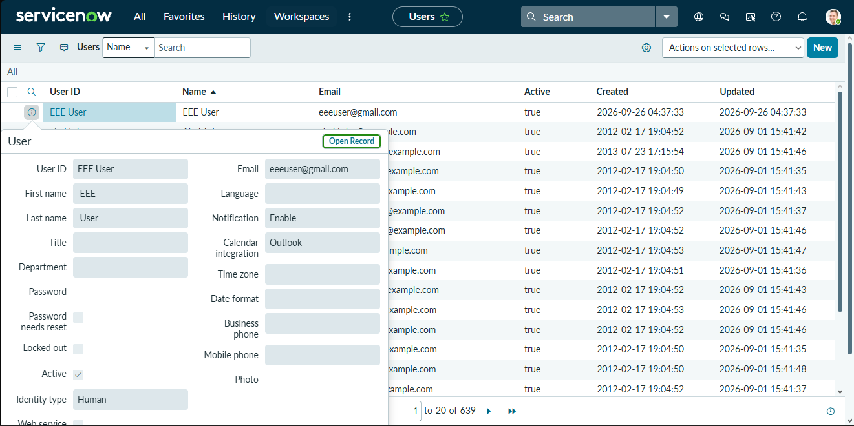
Screenshot – User Creation

ROLES CREATION
Role Creation:
- Navigate to User Administration → Roles
- Click New
- Name: Enter role name as bb1
- Description: Brief role purpose
- Click Submit
- Create other roles also like bb2,bb3,bb4.(follow the same procedure)
- Assign all the roles to the EEE User
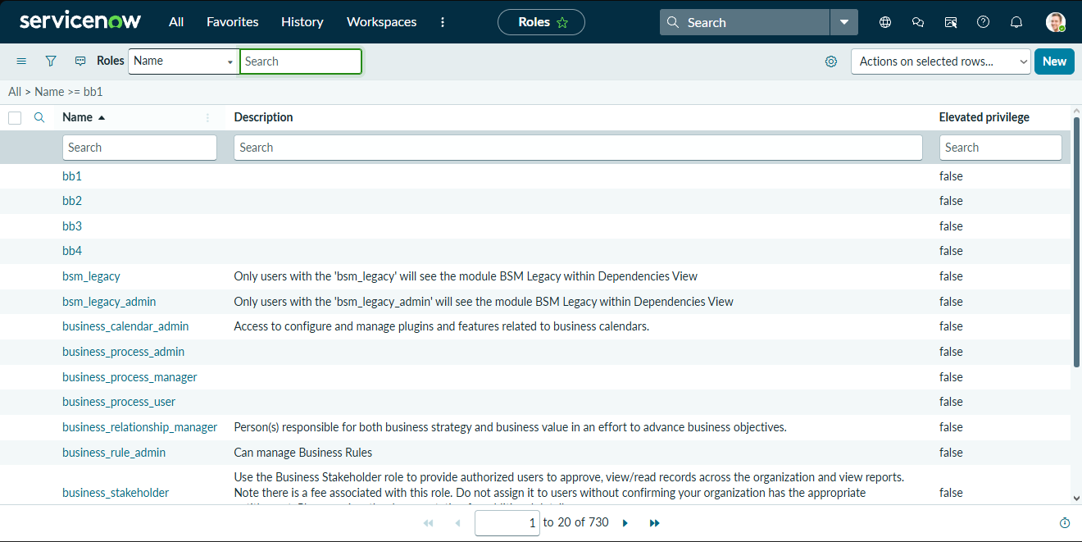
Screenshot – Role Creation

